- Write in a standard form
  - $0.000 004 512$ b. $1 450 000 000$

- Write as a number
  - $7.15×{10}^{4}$ b. $3.9×{10}^{-5}$
- Give your answers in standard form
$a. \left(6×{10}^{-600}\right)×\left(8×{10}^{300}\right)$ b. $\left(3×{10}^{700}\right)÷\left(1.2×{10}^{-400}\right)$
- Give your answers in standard form
$a. \left(2.3×{10}^{-200}\right)+\left(4.15×{10}^{-202}\right)$ b. $\left(7.4×{10}^{701}\right)-\left(2.3×{10}^{700}\right)$
- Solve the following inequality and show the answers on a number line.
$4-2\left(x-1\right)<3$
- Solve the following equations
- $\frac{x^{2}}{9}+1=5$ b. $\sqrt{3x}-1=8$
- Add the following algebraic fractions
  - $\frac{2y-1}{3}-\frac{x-2y}{15}-\frac{x+1}{10}$ b. $\frac{4}{5a}-\frac{1}{2b}+\frac{3}{4ab}$
- Simplify the following algebraic fractions
  - $\frac{7x^{3}y}{24x^{5}}×\frac{(4x{y)}^{2}}{70xy^{2}}$ b. $\frac{12x^{2}y}{15xy^{4}}÷\frac{(2{x)}^{4}}{3x^{4}y}$
- Simplify the following algebraic fractions
  - $\frac{4x^{3}+12yx^{2}}{8xy}$ b. $\frac{3x^{2}y^{3}+15xy^{4}}{4xy+20y^{2}}$
- Find the equation of the line on the diagram below
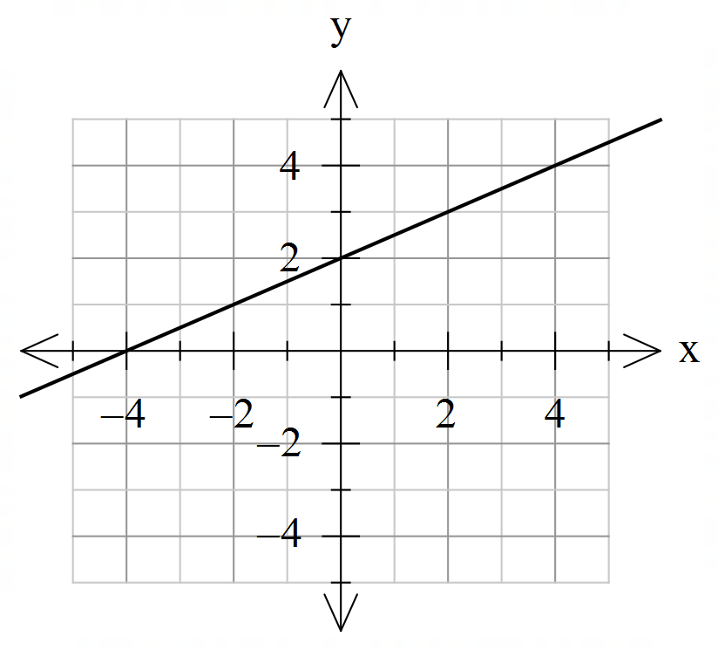
- Gradient of line passing through the points $(5, 7)$ and $\left(a, 10\right)$is 2. Find the value of $a$.
- Find the gradient and $y-$intercept of the line $2y+7x=8$.
- Find equation of line parallel to line $y=\frac{1}{2}x+3 ,$ and passing through point $(-4, 5)$.
- a. Find the $x-$ and $y-$intercepts of line $4y-6x=24$.
b. Hence sketch the line.
- a. Draw lines $y=3x-1$ and $y=-\frac{1}{2}x+3$ on the same set of axes: 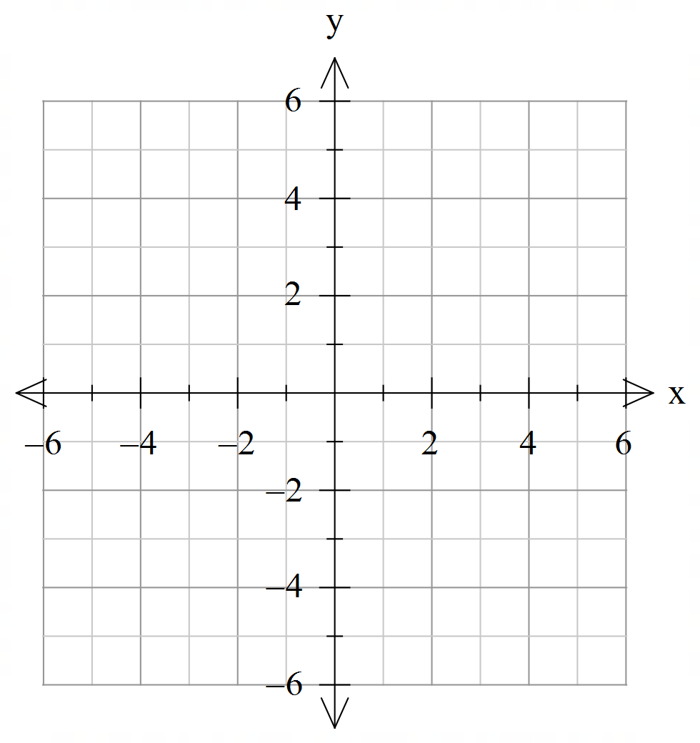
- Hence solve simultaneous equations graphically, using your graph.
$$y=-\frac{1}{2}x+3$$
$$y=3x-1$$
- Find the missing side length in the diagram.
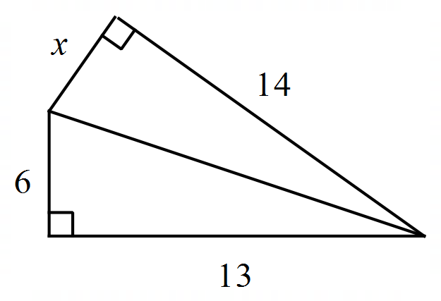

- Find the angle $x$, clearly state the reasoning.
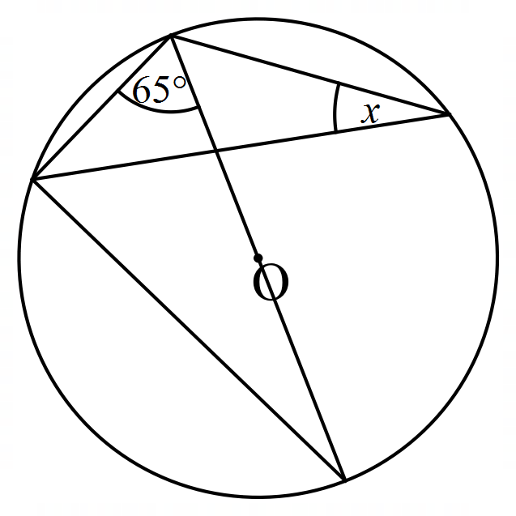
- Solve the following equations
  - $\frac{4x-1}{3}-\frac{x-6}{6}=\frac{x+2}{4}$ b. $\frac{x}{x+2}-\frac{3}{4}=2$
- Solve the following simultaneous equations.

$2x+5y=18$ $3x+4y=11$
$2+y=x$ $5x-2y=1$

